DOCUMENT BASED QUESTION

This question is based on the accompanying documents (1- 10). This question is designed to test your ability to work with historical documents. Some of these documents have been edited for the purposes of this question. As you analyze the documents, take into account both the source of each document and any point of view that may be presented in the document.

Historical Context:
Joseph Stalin is one of the most controversial leaders in world history. Between 1928 and 1941 he transformed the Soviet Union into a modern superpower. His rule is characterized by collectivized agriculture, rapid industrialization, great purges and the establishment of a totalitarian government.

Task: Using information from the documents and your knowledge of global history, answer the questions that follow each document in Part A. Your answers to the questions will help you write the Part B essay, in which you will be asked to answer:
- Identify two programs initiated by Joseph Stalin and for each:
  - Describe the goals of the event or program.
  - Evaluate the positive or negative effects on the USSR.

NOTE: The rubric (scoring criteria) for this essay appears on the next page.

Document Based Question Scoring Rubric

Score of a 5:
- Shows a thorough understanding of the theme or problem
- Thoroughly develops all aspects of the task evenly and in depth
- Is more analytical than descriptive
- Incorporates relevant information from a majority of the documents
- Incorporates substantial relevant outside information
- Richly supports essay with relevant facts, examples and details
- Demonstrates a logical and clear plan of organization; includes an introduction and a conclusion that are beyond a restatement of the theme

Score of a 4:
- Develops all aspects of the task but may do so somewhat unevenly
- Is both descriptive and analytical
- Incorporates relevant information from a majority of the documents
- Incorporates relevant outside information
- Supports the theme with relevant facts, examples and details
- Demonstrates a logical and clear plan of organization; includes an introduction and a conclusion that are beyond a restatement of the theme

Score of a 3:
- Develops all aspects of the task but with little depth or develops most aspects of the task in some depth
- Is more descriptive than analytical
- Incorporates some relevant information from some of the documents
- Incorporates limited relevant outside information
- Includes some relevant facts, examples, and details; may include some minor inaccuracies
- Demonstrates a satisfactory and clear plan of organization; includes an introduction and a conclusion that may be a restatement of the theme

Score of a 2:
- Minimally develops all aspects of the task or develops some aspects of the task in some depth
- Is primarily descriptive; may include faulty, weak or isolated application or analysis
- Incorporates little relevant information from the documents or consists of primarily relevant information copied from the documents
- Presents limited relevant outside information
- Includes few relevant facts, examples, and details; may include some inaccuracies
- Demonstrates a general plan of organization; may lack focus; may contain digressions; may not clearly identify which aspect of the task is being addressed; may lack an introduction and/ or conclusion

Score of a 1:
- Minimally develops some aspects of the task
- Is descriptive; may lack understanding, application or analysis
- Makes vague, unclear references to the documents or consists primarily of relevant and irrelevant information copied from the documents
- Presents no relevant outside information
- Includes few relevant facts, examples, or details; may include inaccuracies
- May demonstrate a weakness in organization; may lack focus; may contain digressions; may not clearly identify which aspect of the task is being addressed; may lack introduction and/ or a conclusion

Score of a 0:
Fails to develop the task or may only refer to the theme in a general way; OR includes no relevant facts, examples or details; OR includes only the historical context and/ or task as copied from the test booklet; OR includes only entire documents copied from the test booklet OR is illegible; OR is a blank paper

Part A: Documents

Document 1
Stalin launched his first Five- Year Plan in 1928 by setting up a planned or command economy. In this speech, Stalin arouses Russian pride to motivate his people.
To slow down would mean falling behind and those who fall behind are beaten. But we do not want to be beaten! One feature of the old Russia was the continual beatings she suffered for falling behind, for her backwardness….
Do you want out Socialist fatherland to be beaten? … If you don’t want this, you must end our backwardness. You must develop a real Bolshevik tempo [speed] in building our Socialist economy. There is no other road.
We lag behind the advanced countries by fifty to a hundred years. We must make good this distance in ten years. Either we do it or we shall be crushed.

1a. Why did Stalin claim it was so important for Russians to develop a socialist economy? [1]
______________________________________________________________________________________________________________________________________________________________________________
1b. What could happen to Russia if they failed to work on his program? [1]
______________________________________________________________________________________________________________________________________________________________________________

Score

Document 2
When the first Five- Year Plan was announced in 1929, targets for industries were set that began rapid industrialization (Twentieth Century History, Tony Howarth, Longman Group Ltd., 1979.)

Industry | 1927- 1928 | Target for 1933
Electricity (milliard kWh) | 5.05 | 17.0
Coal (million tonnes) | 35.4 | 68.0
Oil (million tonnes) | 11.7 | 19.0
Pig-iron (million tonnes) | 3.3 | 8.0
Steel (million tonnes) | 4.0 | 8.3

2a. What was the purpose for setting targets for the production of these goods? [1]
______________________________________________________________________________________________________________________________________________________________________________
2b. Which area was targeted for the biggest change in production? [1]
______________________________________________________________________________________________________________________________________________________________________________

Score
Document 3
The following chart shows the industrial production under the Five- Year Plans.
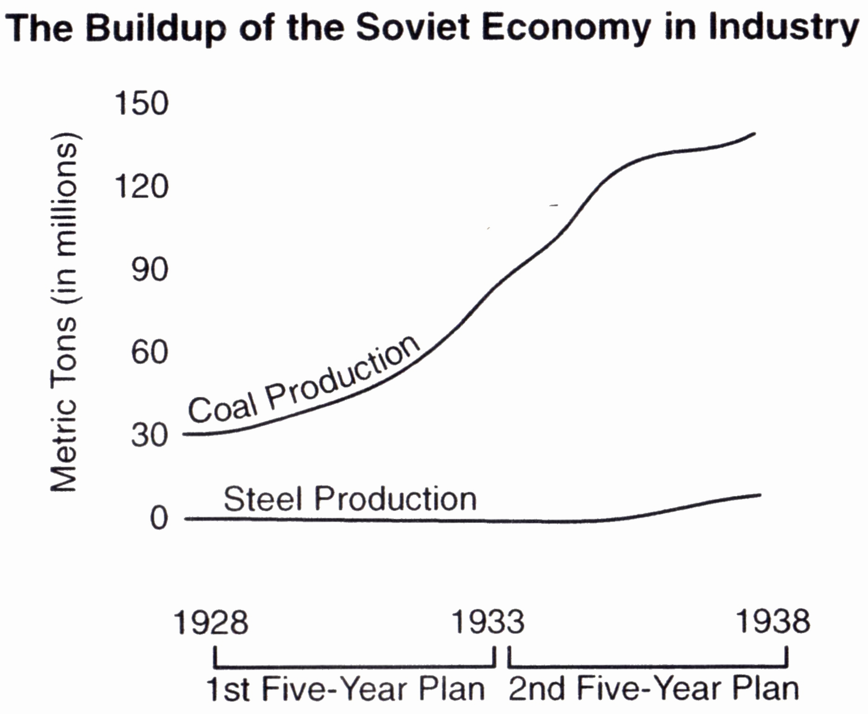

3a. Explain if the Five- Year Plans had the intended effect on production. [1]
______________________________________________________________________________________________________________________________________________________________________________
3b. Which area showed the greatest change in production? [1]

_______________________________________________________________________________________

Score

Document 4
In this excerpt from a 1929 speech delivered by Stalin, he explains the collectivization policy and the need to eliminate the kulaks (wealthy farmers).
The solution lies in enlarging the agricultural units… and in changing the agricultural base of our national economy… The Socialist way, which is to set up collective farms and state farms which leads to the joining together of small peasant farms into large collective farms, technically and scientifically equipped, and to the squeezing out of the capitalist elements from agriculture… Now we are able to carry on a determined offensive against the kulaks, to break their resistance, to eliminate them as a class and substitute for their output the output of the collective farms and state farms.

4a. Why did Stalin believe the kulaks had to be eliminated and replaced with state run farms? [1]
______________________________________________________________________________________________________________________________________________________________________________
4b. Why did he believe the state run farms would be better for Russia? [1]
______________________________________________________________________________________________________________________________________________________________________________

Score
Document 5
The following illustrations show agricultural production during the First and Second Five- Year Plans.
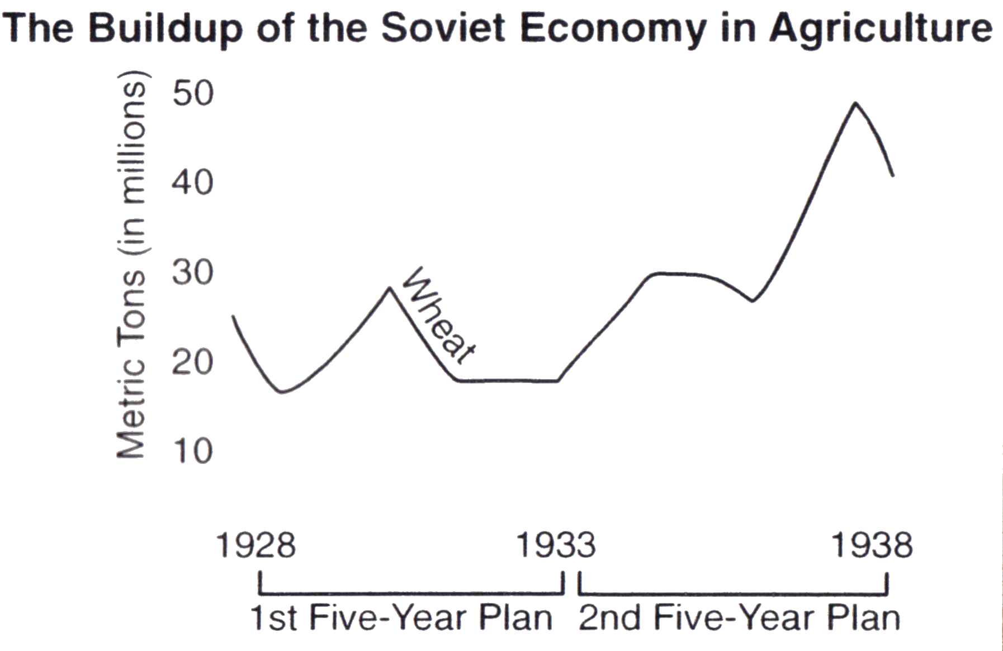
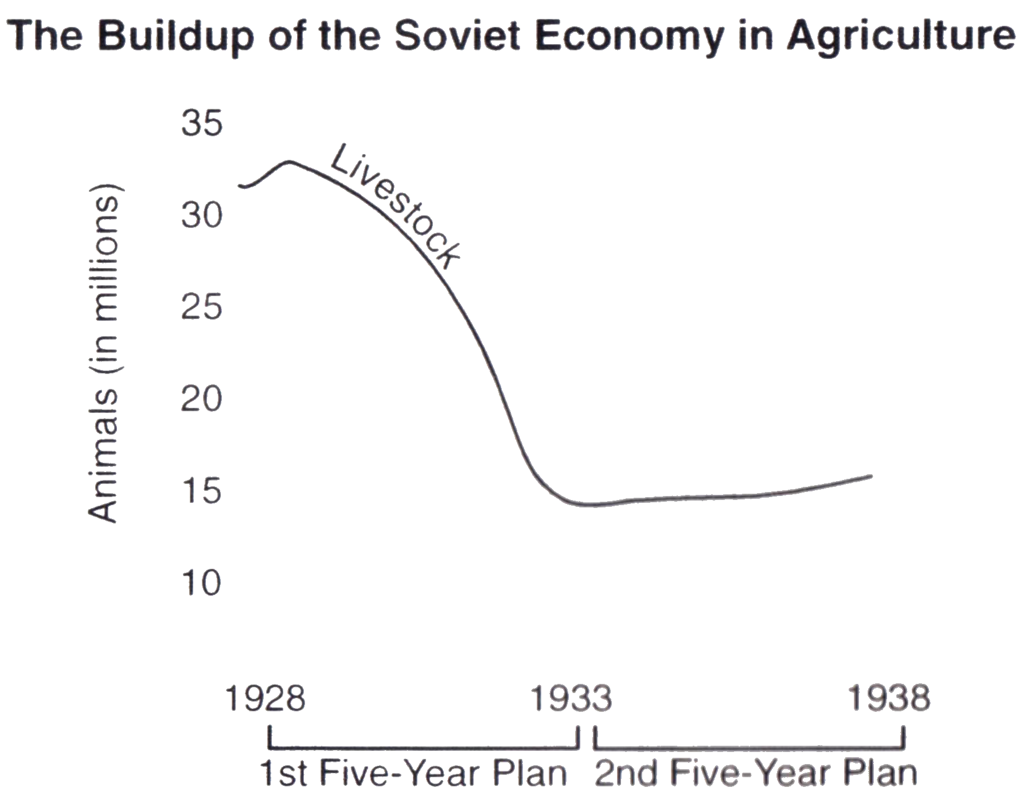

5a. Explain if the Five- Year Plans had the intended effect on production. [1]
______________________________________________________________________________________________________________________________________________________________________________
5b. According to these graphs, did Stalin’s collectivization program for agriculture succeed? [1]
______________________________________________________________________________________________________________________________________________________________________________

Score

Document 6
This excerpt from “Forced Famine in the Ukraine: A Holocaust the West Forgot” by Adrian Karatnycky, was printed in The Wall Street Journal, on July 7, 1983.
Today, reliable academic estimates place the number of Ukrainian victims of starvation at 4.5 million to 7 million… The famine was in part the by-product of Stalin’s relentless drive to collectivize Soviet agriculture. The famine was a clear result of the fact that between 1931 and 1933, while harvests were precipitously declining, Stalin’s commissars continued to… confiscate grain. Peasants were shot and deported as rich, landowning “kulaks”… While the drive to collectivize agriculture was a wide- ranging phenomenon common to the entire U.S.S.R., only in the Ukraine did it assume a genocidal character. Indeed there can be no question that Stalin used the forced famine as a part of a political strategy whose aim was to crush all vestiges of Ukrainians national sentiments.

6. According to the author, what were two reasons for Stalin’s elimination of the Ukrainians between 1931 and 1933? [2]
1._______________________________________________________________________________
2. _______________________________________________________________________________

Score
Document 7
This excerpt is from The Land of the Soviets, published in the U.S.S.R., which gives another perspective of the collectivization.
The radical step forward by the majority of the peasantry towards a collective way of life was taking place against the backdrop of a bitter struggle between Soviet power and the kulaks. The [kulaks] stooped to all possible means to wreck the collectivization campaign. They murdered collective farm activists and Party and government officials sent to the villages to help the peasants; they set fire to the collective farm buildings; they poisoned the cattle and destroyed farm machinery… The exploiter class- the rural bourgeoisie- was finally abolished…

7. Identify two ways the kulaks interfered with the collectivization program.[2]
1._______________________________________________________________________________
2. _______________________________________________________________________________

Score

Document 8
This excerpt from The Land of the Soviets, published in the U.S.S.R. describes the results of the Five- Year Plans.

The fulfillment of the first and second Five- Year Plans strengthened the Soviet Union’s economic position and turned it into a powerful industrial state… In 1937 the industrial output of the USSR considerably exceeded that of the capitalist countries. By 1937 the Soviet Union was the first country in Europe and the second in the world in the volume of industrial production… Socialist industrialization was accompanied by the rapid growth of the working class, and made it possible to liquidate unemployment. In 1940 there were 9,971,000 industrial workers, which was nearly three times more than in 1928. The working class was also changing: its efficiency, technical and cultural levels were growing rapidly.

8. According to the author, what were two results of the Five- Year Plans? [2]
1._______________________________________________________________________________
2. _______________________________________________________________________________

Score

Document 9
In this excerpt, the French ambassador to the Soviet Union describes the public trials that were part of the “great purges” of Stalin.
I personally attended the second and third Moscow trials, those of 1937 and 1938… Pyatakov [another defendant] arose… confessed… to a number of crimes. Did these “confessions” carry any share of truth? It is possible that the accused were hostile to Stalin’s regime… But the lessons they recited must have been forced from them… it is more likely that the GPU [secret police] touched each at his weak point. It is also probable that the accused gave in to some form of pressure… Some would give in to save their families, others in hope of saving their own lives.

9a.What indication is there that the French ambassador doubts the confessions given in these trials? [1]
______________________________________________________________________________________________________________________________________________________________________________
9b. What methods were used to influence defendants to confess to crimes? [1]
______________________________________________________________________________________________________________________________________________________________________________

Score

Document 10
This poster was part of a propaganda campaign to glorify Stalin.
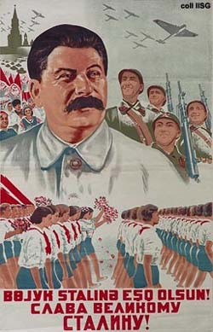

Long Live the great Stalin!

10a. How does this poster portray Stalin and his influence on the USSR? [1]
______________________________________________________________________________________________________________________________________________________________________________
10b. What are the purposes of portraying Stalin in posters such as those pictured above? [1]
______________________________________________________________________________________________________________________________________________________________________________

Score

Part B
Essay
Directions: Write a well- organized essay that includes an introduction, several paragraphs and a conclusion. Use evidence from at least six documents in your essay. Support your response with relevant facts, examples and details. Include additional related information.

Historical Context:

Task: Using information from the documents and your knowledge of global history, write an essay in which you:
- Identify two programs initiated by Joseph Stalin and for each:
  - Describe the goals of the event or program.
  - Evaluate the positive or negative effects on the USSR.

Guidelines:
In your essay, be sure to
- Develop all aspects of the task
- Incorporate information from at least six documents in the body of the essay
- Incorporate relevant outside information
- Support the theme with relevant facts, examples, and details
- Use a logical and clear plan of organization, including an introduction and conclusion that are beyond a restatement of the theme

