New England Colonies
ECONOMY:  - Cottage Industry (manufactured homemade goods)  - Practiced subsistence farming (grew just enough for family and little for profit)  - Abundance of natural resources (timber, iron, fish, fur) led to growth of trade, shipbuilding, iron works, etc. | GEOGRAPHY:  - cold climate & thin, rocky, hilly soil  - lots of natural harbors  - The bad farmland/geography led to the growth of manufacturing economy. | SOCIAL/RELIGIOUS:  - Pilgrims came for religious freedom  - Mostly intolerant to outsiders/other religions  - strong work ethic

1620- Plymouth was established by Massachusetts Bay Company
The Mayflower brought Pilgrims
The Mayflower Compact established self-government.
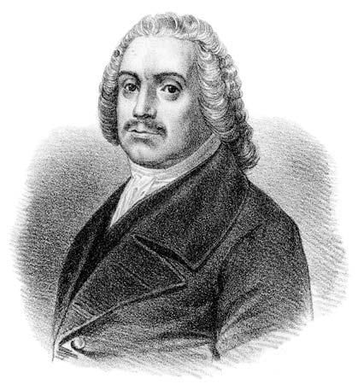
Dissenters
Roger Williams: Cofounder of _________ _________. Believed in “separation of church & state.” 1st abolitionist.

Thomas Hooker: Founded _________________. 1st Constitution called _______________________ Orders of Connecticut. Strongly advocated for suffrage. Believed the government should answer to the __________________.

Anne Hutchinson: She was kicked out for speaking her mind and questioning the church. “God speaks to all- not just men or church leaders.” Led bible studies against church leaders. Co-founder of ____________ __________.

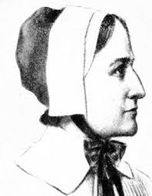
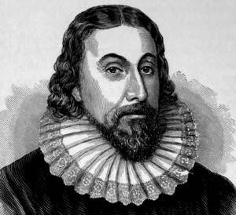
Dissenters got the boot- got kicked out
People have a voice
-Life was regulated by strict, ___________
_____________.
-AKA “City Upon a Hill”
-John Winthrop- MA Governor
-Puritans (Purify the Church)
-Separatists (Separate from the Church)
-Pilgrims made the Journey for ___________ reasons.
* Developed schools, churches, & town halls.
Town Halls allowed for town meetings-lead to formation of democratic ideas.
Boston, MA

